Switchboards and Form Menus
Chapter
8

Macros are used extensively in Access to perform actions such as opening forms or tables, running queries, running reports, printing reports or closing the database. Macros enable users who have little knowledge of Access to operate the database effectively.

Macros can be created in three ways;

- Using the Command Button tool and/or the Switchboard manager
- Creating a Macro on the Macro tab
- Writing a Macro in Visual Basic Language

In this chapter you will use the first option. In the next chapter you will create macros on the Macro tab and then assign them to buttons. The third option is beyond the scope of this book.

Microsoft Access has a user interface menu called a Switchboard. Switchboard forms are used for a menu system to move around the various objects in a database. A switchboard is simply a plain form with command buttons that have macros assigned to them.

When the New Database Wizard is used to create a new database Access automatically creates a Switchboard menu for the database. The picture below displays the Main switchboard created when the Orders Wizard is used to create a database and various reports, queries and tables.

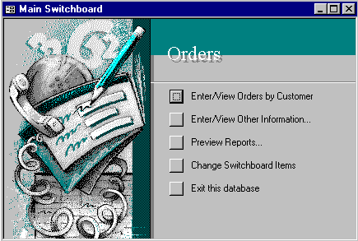
Switchboards are useful for directing users who have little knowledge of the database. A good switchboard should be able to direct users to appropriate reports and data entry points.

Switchboards are automatically created when a Wizard is used to create a new database. You can also create your own switchboards for an existing database. As with any form you can use a Wizard to create it or start it from scratch using design tools.

Using a Switchboard to Perform Operations in a Database

Before you learn how to create your own switchboard we will look at how they work.

You already have a switchboard setup in the Orders database in your student files.

- Open the file Orders
The Main switchboard will appear.
Enter/View Orders by Customer
- Click on the first button for Enter/View Orders by Customer

The Orders by Customer form appears that displays a customer and their respective orders.
Close
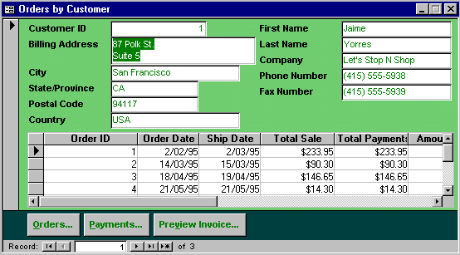

- Click on the Close button to close the form

The next option is to display another switchboard which is indicated by the three dots after the text. The third option is also to display another switchboard.

- Click on the Enter/View Other Information button to display that switchboard
Enter/View Other Information
Return to Main Switchboard
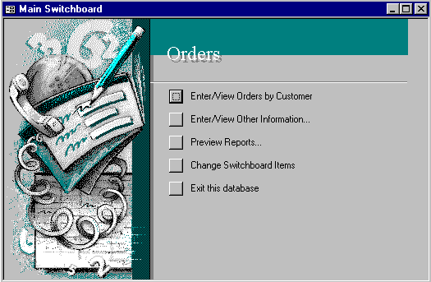

The next switchboard will appear.

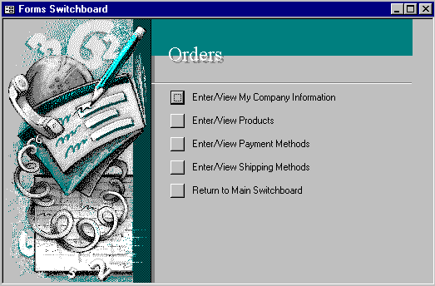
There are buttons to display the various forms. There is also a button at the end of the list to Return to the Main Switchboard.

- Open and Close some of the forms then click on the Return to Main Switchboard to display it

Modifying a Switchboard created by a Wizard.

You will see on the Main Switchboard a button for Change Switchboard Items.
Change Switchboard Items
- Click on Change Switchboard Items

- Click on Reports Switchboard then Edit
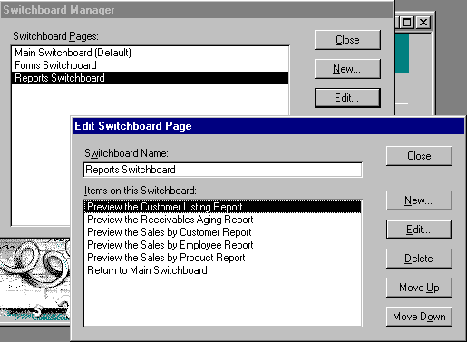
Edit
Reports Switchboard
Edit
Preview the Customer Listing Report
- Click on Preview the Customer Listing Report then Edit

The Edit Switchboard Item dialog box appears with the text from the Switchboard highlighted. Notice the command box says Open Report and the Report box says Customer Listing which is the name of the Report. You are simply changing the text that appears on the switchboard.
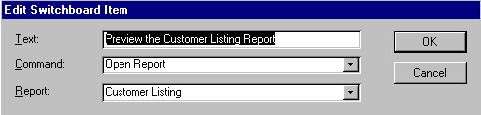

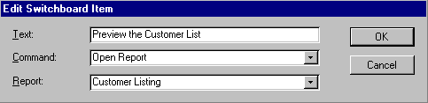
- Click at the end of the text and delete ing Report so the text reads as shown here

- Click on OK

- Click on Close

- Click on Close again to return to the Main Switchboard

- Click on Preview Reports to display that switchboard – the switchboard menu will now read Preview the Customer List

- Click on Return to Main Switchboard

Practice : Change Text

- Click on Change Switchboard Items
- Click on the Forms Switchboard then Edit
- Click on Enter/View My Company Information and click on Edit
- Change the text to read Dandy Pty Ltd details

- Click on OK then Close and Close again to return to the Main Switchboard

- Click on Enter/View other Information

Dandy Pty Ltd Details should appear at the top of the list.

Delete an Item from the Switchboard

You can delete options from the switchboard very simply. Suppose you do not want the option Enter/View Shipping Methods on the Switchboard.

On the Main Switchboard….
- Click on Change Switchboard Items to display the Switchboard Manager

- Click on Forms Switchboard and Edit
- Click on Enter/View Shipping Methods
Forms Switchboard
Edit
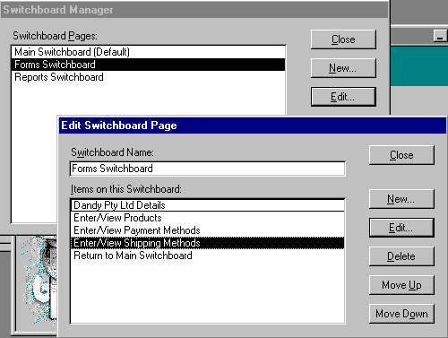
Enter/View Shipping Methods
Delete
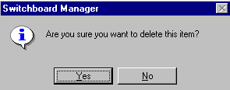
- Click on the Delete button

- Click on Yes to the prompt that appears

- Click on Close then Close again to return to the Main Switchboard

- Click on Enter/View Other Information to display that switchboard – the Shipping Methods option will now be gone

Note: The table of Shipping methods still exists – the macro button to display it just removed

- Click on Return to Main Switchboard

Practice : Repeat the steps to Delete the item Enter/View Payment Methods

Add a New Item

You can also add new items on the Switchboards.

- Click on Change Switchboard Items on the Main Switchboard
- Click on the Forms Switchboard in the list then click on Edit

- Click on New

- Enter the text as shown below in the Text box

- Click on the droplist button of the Command box and click on Open Form in Edit Mode

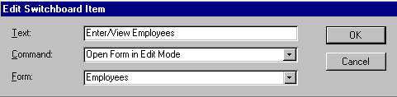
- Click on the droplist button of the Form box and click on Employees (this is a form that already exists
Enter/View Employees Details
Text
Command
Form

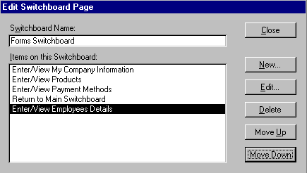
- Click on OK
The new button appears in the list

The new button appears in the list.

- Repeat to create a New item as shown here
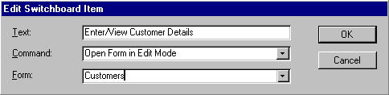
- Click on OK

- Click on Close and Close again to return to the Main Switchboard
- Click on the Enter/View Other Information button on the switchboard – the Forms switchboard will be displayed with the new option buttons as shown on the following page

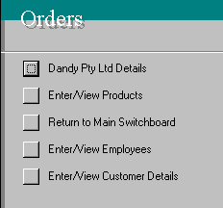
Change Order of Items

In the process of adding, deleting etc., you may decide to reorder the items on the Switchboard. In the example shown to the right it would be preferable to have Return to Main Switchboard at the end of the list.

- Click on Return to Main Switchboard
- Click on Change Switchboard Items

- Click on Forms Switchboard then click on Edit

- Click on Enter/View Customer Details
- Click on the Move Up button until the item is at the top of the list
- Click on Return to Main Switchboard
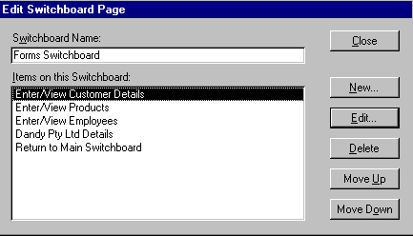
- Click on the Move Down button until the item is at the bottom of the list
Move Up
Move Down
Use the Move Up and Move Down button until the items are in order as shown.
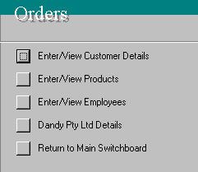
- Continue to use the Move Up and Move Down buttons on the items until it is in the same order as shown above

- Click on Close then Close again

- Click on Enter/View Other information to check the effects

- Click on Return to Main Switchboard

Create a New Switchboard Page

So far you have been working with existing switchboard pages. You can also create new pages to add further options to the menu system. For example you will create a new Menu page for Customer Operations. It will contain a macro button to open Customer Orders form and a Customer List.

On the main Switchboard…..

- Click on Change Switchboard Items
- Click on New
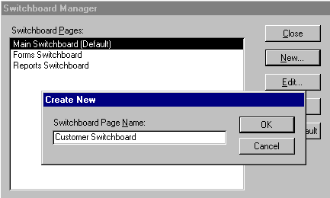
- Type Customer Switchboard for the name
New

- Click on OK
Now we have to add items to this switchboard otherwise it will simply remain a blank page.

- Click on Customer Switchboard then Edit
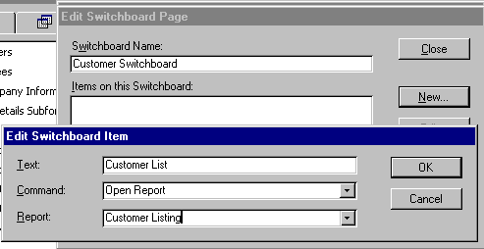
- Click on New
- Enter the Text, Command and Report as shown to the right

- Click on OK then Close

Practice : Add another Item to the Customer Switchboard

- Click on Customer Switchboard then Edit
- Click on New
- Enter the Text, Command and Report as shown below

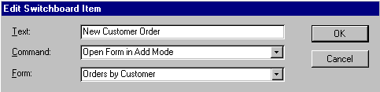
- Click on OK

Create a Return to Main button on the Customer Switchboard

You will also need a button to get you from the Customer Switchboard back to the Main switchboard.

- Click on New
- Enter Text, Command and Form as shown below

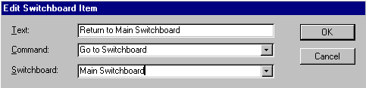
- Click on OK then Close

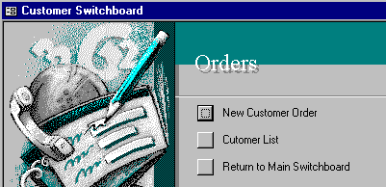
Your Customer Switchboard looks like this. You can’t see it yet – a button on the Main Switchboard must be created to display the new menu.

Create a Button on the Main Switchboard to Open the Customer Switchboard

You must insert a button to get from the Main switchboard to the Customer switchboard so you can use it

With the Switchboard Manager open….

- Click on Main Switchboard in the switchboard list
- Click on Edit
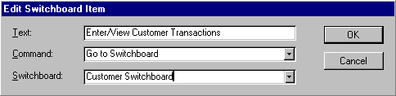
- Click on New and enter the following details in each of the Text, Command and Switchboard boxes

- Click on OK
- Click on the Move Up button to make it the second item in the menu list
- Click on the Enter/View Orders by Customer item then click on Delete because this item is now on the Customers switchboard
- Click on Close and Close
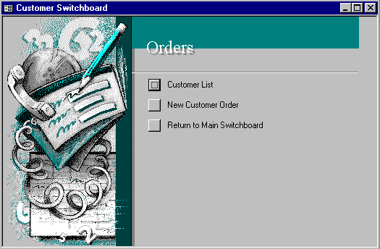
- Try out your new switchboard and items
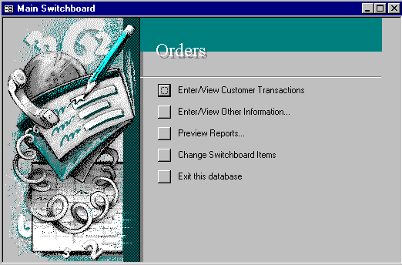

In this section you have been modifying a Switchboard system that was already created for you. In the next section you will learn how to create a Switchboard menu System from scratch.

Create a Switchboard

- Open the database file Handy Harry

- Click on Tools ➢ Database Utilities ➢ Switchboard Manager in the Menu bar

The following prompt will appear on the screen.

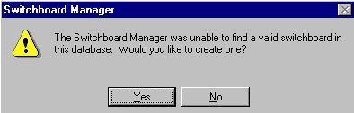
- Click on Yes

The Switchboard Manager window will appear. This is where you enter the switchboard forms.

- Click on Edit

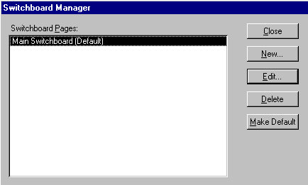
Edit
The Edit Switchboard Page dialogue box will appear.

- Click on New to create a new option for this page.

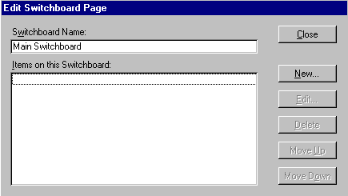

The Edit Switchboard Item dialogue box will appear. The text you enter in the Text box will appear on the switchboard menu.
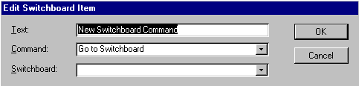

- Enter the Text as shown below
- Click on the droplist button for the Command box and click on Open Form in Add Mode – this will open the form with blank record waiting for new details to be entered

- Click on the droplist button for Form and scroll down and click on Workorders by Customer
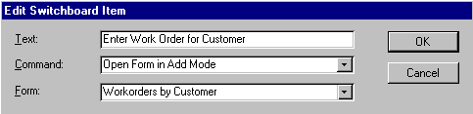
- Click on OK

- Click on Close then Close to return to the Database window

- Click on the Forms tab

The new Switchboard form will appear in the list

- Double click on Switchboard to Open it
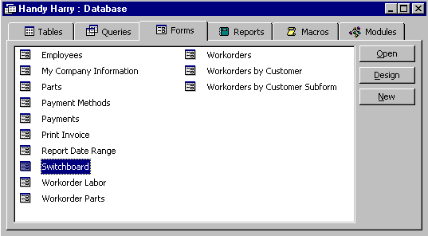
New Switchboard form

The Switchboard from will appear with the option we just entered.
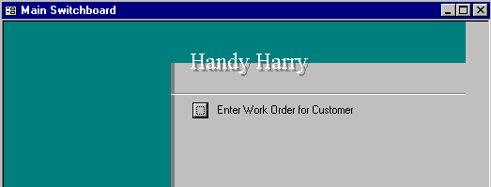

- Click on Tools➢Add Ins ➢ Switchboard Manager in the Menu bar to display the Switchboard Manager

You can now add more commands and sub menus as we did in the previous section.

- Close the Switchboard Manager

Creating a Switchboard Form from Scratch

So much for the Switchboard Manager. What if you want to create your own style of Switchboard menus.

- Open the Orders database

- Click on the Forms tab in the database window
- Click on New
- Click on Design View
- Click on OK leaving the Table/Query box blank
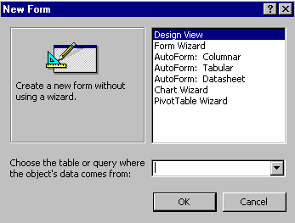

The new blank form will appear ready for you to work on.

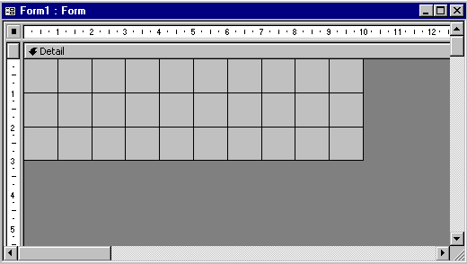
- Click on the box where the rulers meet so a black square appears to indicate the entire form is selected

- Click on the Properties button on the toolbar to display the properties for the form
Properties

Make the following selections for each property.
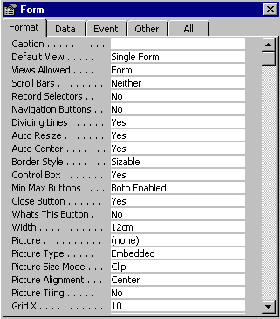
Note that for Scroll Bars – the setting is Neither
Record Selectors – No and Navigation Buttons – No. We use these setting because the form is not to display records, so these buttons are not required.

- Click on File➢ Save and enter the name Main then click on OK
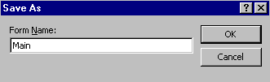

- Click on File ➢ Close

Formatting the Form

You can format the Form as covered in the chapter on Designing Forms. You can add labels and pictures if required.
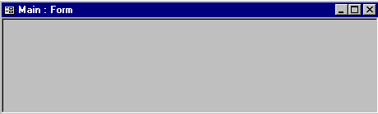
- Click on the Design button

- Drag the lower border so the form is about 7 cm deep
- Use the Label button to create a heading Just Dandy Pty Ltd
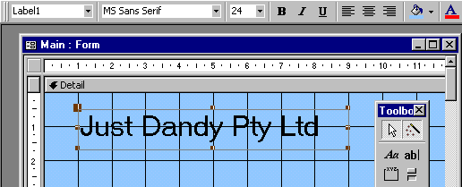
- Format the Label Font Size to be 24 point
Fill/Back Color
Font Size

Label
- Click on Fill/Back Color button on the toolbar and select a color for the background

Inserting a Graphic

- Click on Insert ➢ Picture in the Menu bar
- Click on the file to be inserted – Jelly Beans in this case
- Click on OK
- Move and resize as necessary

Create a simple Command button

Now to create some buttons for the menu.

- Click on the Control Wizard button on the Toolbox until it is pressed in

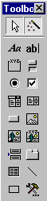
- Click on the Command button tool in the Toolbox
Control Wizard

- Use the mouse to create a small rectangle on the form where the first command is to appear – the Command Button Wizard will start
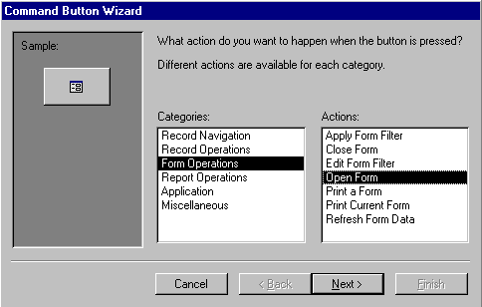
Command Button
Form Operations
Open Form
Next
- Click on Form Operations in the Categories list
- Click on Open Form in the Actions list (this list varies depending on the Category chosen)

- Click on Next
- Click on Orders by Customer then Next
Orders by Customer
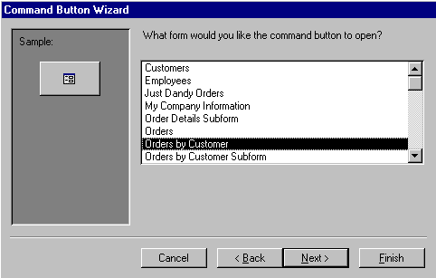

- You have a choice here on how the form will be displayed when opened. Check that Open the form and show all the records is selected then click on Next
Open the form and show all records
Text will appear on the button
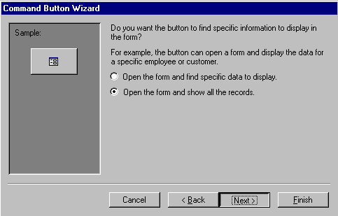

- Click on the Text option and type Customer Orders
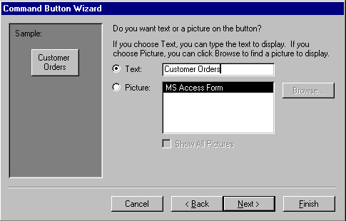
- Click on Next

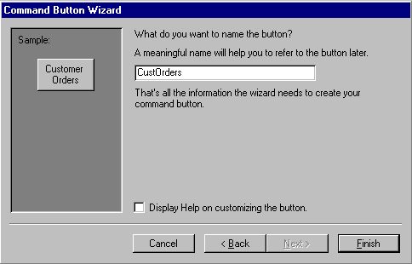
- Type CustOrders as a name for the button

- Click on Finish

- Click on the Form button on the toolbar to display the form

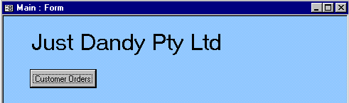

- Click on the Design View button to return to the Form design

Report Operations

You can put buttons on the switchboard that will perform various actions with reports.

- Click on the Control Wizard button on the toolbar until it appears to be pressed in

- Click on the Command button tool in the Toolbox
Control Wizard

- Use the mouse to create a small rectangle on the form where the first command is to appear – the Command Button Wizard will start

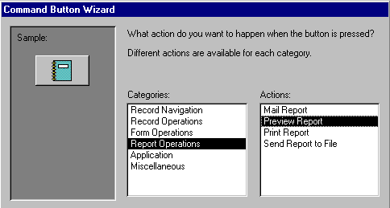
- Click on Report Operations to display various actions for Report Operations
Command button
Report Operations
Preview Report

- Click on Preview Report
- Click on Next

- Click on Receivables Aging then click on Next

- Edit Button Text to read Preview Receivables Aging Report then click on Next

- Complete remaining steps appropriately

The button will appear on the form – you can resize and move it appropriately.

Buttons to Close the Database and Access
Control Wizard
You can create a button that will close the database.

- Click on the Control Wizard button on the toolbar until
it is pressed in

- Click on the Command button tool in the Toolbox

- Use the mouse to create a small rectangle on the form where the first command is to appear – the Command Button Wizard will start

- Click on the Application category

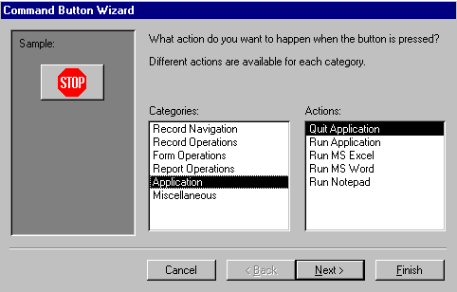
The various actions you can assign to the button are displayed.

You can use this to exit the Access Database.

- Click on Quit Application then click on Next
Applications category

- Click on the Text option and type Exit this Database

- Click on Next then type a name for the control - ExitdBase

- Click on Finish

Opening the Main Switchboard at Startup

You can set the database so that the Main form you have just created is displayed on opening the database file.

- Close all objects so only the database window is open
- Click on Tools➢Startup in the Menu bar
- Click on the Display Form box
- Click on the droplist button and click on the name of the form
- Click on OK

Main
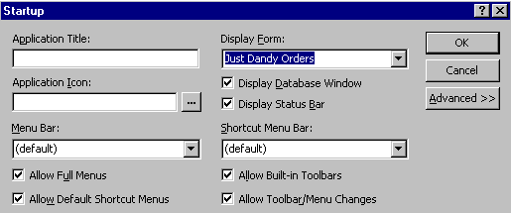
- Close the database

- Open the Orders database – the Main form should load up automatically

The buttons we have created can be inserted on any form.

